Week 23: 01/23/17 – 01/27/17 Flashbacks

Flashback Instructions: Read and analyze each day’s questions and possible answers carefully. Identify the correct letter response to each question and fill in the GradeCam answer sheet for TODAY’S questions only.

Monday (RI/L.7.4): Analyze each of the following sentences and identify which uses the vocabulary terms correctly:

1.) ALTERED - PROLONGED
- Carley prolonged her speech because she altered it was too short.
- Deer use their alters to fight for prolonged survival in the wild.
- The trip to grandma’s house was prolonged because we altered the route we usually take.
- Sentence A and C are both correct.

2.) CHRONIC - REFRAIN
- Dustin’s chronic illness caused him to have to refrain from many activities.
- You should always refrain from being a chronic liar.
- You should refrain from listing the chronic order of events unless you are asked to do so.
- Sentence A and B are both correct.

3.) BLUNT - REMORSE
- George felt remorse for being so blunt with Terry yesterday.
- Jerry’s joke was so blunt, Tommy’s remorse caused his stomach to hurt!
- Tallia’s joke has so much remorse, it caused Heidi’s stomach to feel blunt.
- None of these sentences are correct.

4.) AMPLE - OPTIMISTS
- Because my brother is an optimist and I am a pessimist, we have ample arguments about life.
- Even with all the negative things going on in the world, there are still ample people who are optimists.
- Optimists usually are filled with ample good advice.
- All of these sentences are correct.

5.) CHRONOLOGICAL – PRETENSE
- Shirley did not tell me the truth about my family’s history, so the chronological order of births was built on pretense for my family tree project.
- The chronological performance was the most entertaining pretense we had ever watched.
- My little brother is a chronological liar, so I knew everything he said was pretense.
- Sentence A and C are both correct.

Tuesday (RI/L.7.3 and RI/L.7.6): Choose the BEST answer. Be sure to read each question and possible response carefully.

6.) Identify the part of a story that gives background information to the reader.
- denouement
- climax
- rising action
- exposition

7.) Identify the part of the story where the main conflict reaches its highest point.
- falling action
- resolution
- climax
- rising action

8.) Compare the following plot diagram orders and identify which one represents a true plot diagram.
- Denouement -> Rising Action -> Conflict -> Falling Action -> Denouement
- Exposition -> Rising Action -> Climax -> Falling Action -> Denouement
- Exposition -> Rising Action -> Conflict -> Falling Action -> Denouement
- None of the above represent a true plot diagram

9.) Explain who the narrator of a story told in 3rd-person point-of-view (POV) is.
- The narrator would be one of the characters in a story told in 3rd-person POV, and have intimate knowledge of the situation, but not the internal thoughts of other characters.
- In a story told in 3rd-person POV, the narrator is the main character and only knows his/her own thoughts and about events they have witnessed or heard of.
- A narrator of a story told in 3rd-person POV is not part of the story, and usually knows everything about the background and all characters’ thoughts.
- None of these explain the role of a narrator of a 3rd-person POV story.

10.) After reading the poem “Caged Bird” the biography “Frederick Douglass: From Slavery to Freedom”, the reader can infer which of the following statements about the authors’ POVs?
- Both authors believe all black people come from families who were enslaved.
- Both authors believe slavery is demeaning to any human and freedom is worth fighting for.
- Both authors believe slavery is only acceptable under certain circumstances.
- There is no common inference the reader can make by comparing these two texts.

Wednesday (RI/L.7.5): Identify what type of writing each of the following items are used in.
***Please pay attention to number order of these questions before choosing your response!***

11.) Stanzas
- Short Stories
- Auto-biographies
- Poetry
- All of these types of writing use stanzas.
12.) Paragraphs
- Short Stories
- Auto-biographies
- Narratives
- All of these types of writing use paragraphs.
13.) True information gathered about a real person’s life
- Auto-biographies
- Biographies
- Non-Fiction
- All of these types of writing can use information gathered about a real person’s life.
14.) Narration
- Auto-biographies
- Non-Fiction
- Poetry
- Narration can be used in all types of writing.

Thursday (RI/L.7.9): Read and analyze the following questions and possible responses carefully, then choose the BEST answer.

15.) How would you create a VinnDiagram, in order construct a correct contrast between texts/media?
- Include any information that is different between the two texts/medias being examined.
- Include any information that is similar between the two texts/medias being examined.
- Use a 1) -> 1) comparison of common characteristics that identify differences in important details between the two texts/medias being examined.
- None of the above provide correct contrast on a VinnDiagram.

16.) How would you create a VinnDiagram, in order to construct a correct comparison between texts/media?
- Include any information that is different between the two texts/medias being examined.
- Include only important information that is similar between the two texts/medias being examined.
- Identify 1) -> 1) comparisons of common characteristics that identify similarities between the two texts/medias being examined.
- None of the above provide correct comparison on a VinnDiagram.

17-20) Analyze the images below and choose the correct response for information as it would synthesized into a VinnDiagrams.:

Image I) 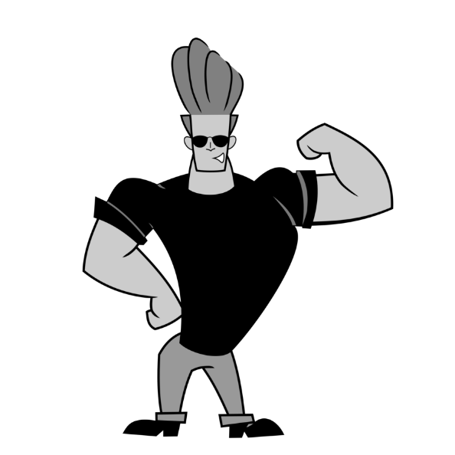 Image II) 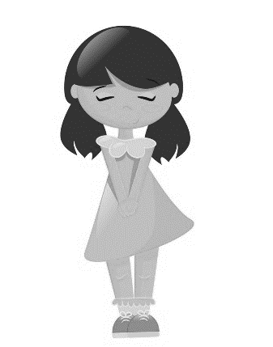

17.) Identify two ways the images contrast.:
- Image I is of a tall male, and image II is of a short female.
- Image I is of a male with lighter hair, where image II is of an female with darker hair.
- Image I is of a muscular male, and image II is of fragile female.
- All of the above correctly identify two ways the images contrast.
- None of the above correctly identify two ways the images contrast.

18.) Identify one way the images compare. Choose the answer that only shows comparison.
- You cannot see the eyes of the characters in either image.
- Image I is of a male and image II is of a female.
- Both images are of human characters, but Image I is of a male and Image II is of a female.
- Both A and C correctly identify one way the images compare.
- None of the above correctly identify one way the images compare.

19.) When constructing a VinnDiagram, where do you log the contrasts?
- In the overlapping of the circles.
- In the exterior portions of the circles that do not overlap.
- In the title.
- You do not log contrasts in constructing a VinnDiagram.

20.) Read and analyze the following definitions and identify which is the correct representation of how you present information when conducting compare/contrast in a VinnDiagram.
- Compare = When texts/medias have a common characteristic that is similar; Contrast = When texts/medias have a common characteristic that is different.
- Compare = When texts/medias have a common characteristic that is different; Contrast = When texts/medias have a common characteristic that is different.
- Compare = When texts/medias have a common characteristic; Contrast = When texts/medias have different characteristics.
- Compare = When texts/medias have different characteristics; Contrast = When texts/medias have common characteristics.

Friday: First, since we have reviewed our standards this week, go back and re-examine all previous Week 23 FBs to make sure you have selected the best answer for each question. Turn Week 23 FBs answer sheet into the tray and then get a clean answer sheet and test page from the front table for today’s vocabulary pre-assessment. ***You will need to answer on the appropriately labeled GradeCam answer sheet, titled “BVS Pre-Assessment 2.11”. Make sure you have turned in both “Week 23: 01/23/17-01/27/17 Flashbacks” and “BVS Pre-Assessment 2.11” as well as any missing or makeup work from previous assignments into the tray. If you finish early, please show me you are ready to proceed to the library by quietly reading to yourself until everyone is finished.

30 points possible (M-Th Week 23 FBs = 20, Week 24 BVS PreAssessment = 10)

Week 23: 01/23/17 – 01/27/17 Flashbacks

- C
- D
- A
- D
- D
- D
- C
- B
- C
- B
- C
- D
- D
- D
- C
- B
- D
- A
- B
- A

Name:____________________
Date:_____________________
Period:___________________

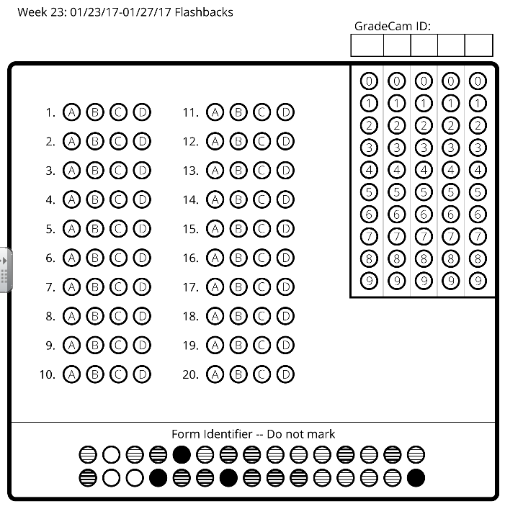

Name:____________________
Date:_____________________
Period:___________________

